**Pushing an image to AWS ECR from GitLab**

1)Configure AWS ECR as below

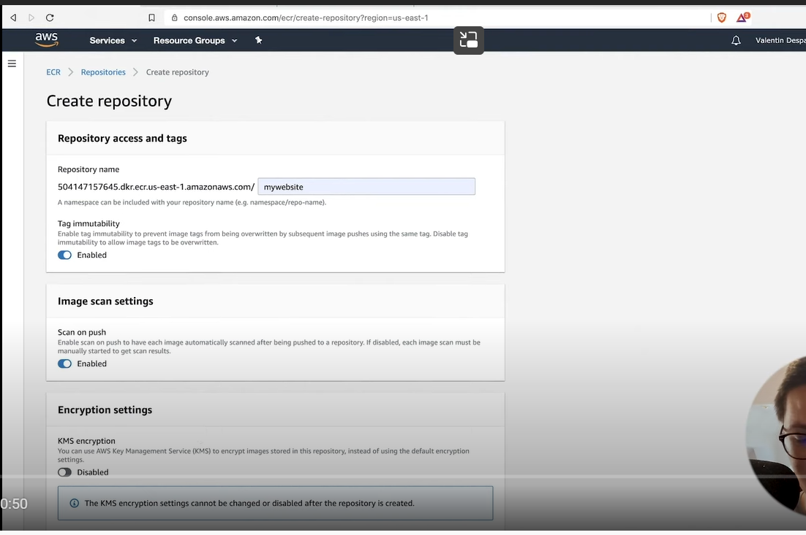

2)Create a .gitlab-ci.yml file as below

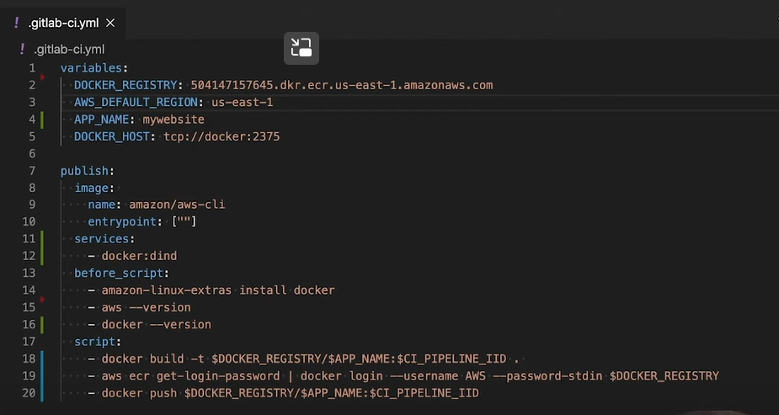

3)Create a IAM role in AWS and assign ECR full permission to the user and copy access key and secret key then configure it in Gitlab variable section